Dear STARTALK Families,
Congratulations on giving your child the gift of this STARTALK program! Through a variety of engaging activities, your child will begin to communicate in another language and explore other cultures.
Before the program begins, you may want to chat with your child using some of the prompts, photos, and links on the following pages. There are no correct answers, as all of us, young and old, bring different experiences to the language learning table. This is simply an opportunity to have a conversation with your child to begin reflection about languages and cultures all around us, so keep it fun and casual. For example,
- Talk with your child about people you already know who speak other languages (your own family; neighbors; people in your community; other children at school; characters on TV, in books, or in the movies)
- Talk with your child about experiences with other languages and cultures (e.g., going to a local restaurant, participating in a cultural event, using products from the culture, enjoying sports and leisure activities just like children of the language to be studied).
- Explore what animals sound like in different parts of the world http://www.esl-languages.com/en/animal-sounds.htm (especially with primary children, although the author’s husband also got a kick out of this!)
- Use the photos as springboards for remembering where you have seen goats, eaten she kebob, or seem a similarly beautiful mountain.
- Talk with your child about places your family has lived or traveled to (if applicable to your child) and what he or she remembers about those places
- Identify cars, books, foods, and animals in your own community that reflect various cultures.

Chinese
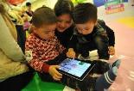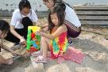

Russian
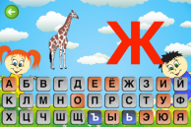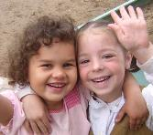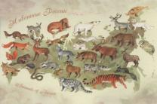

Hindi
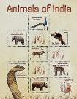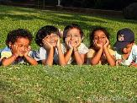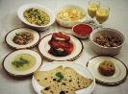
Turkish
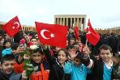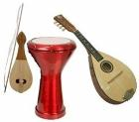

Persian
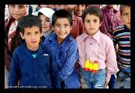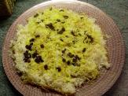

Dari
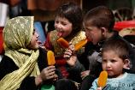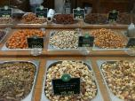

Urdu in Pakistan
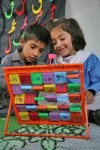

Swahili
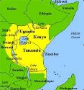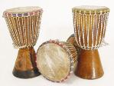

Spanish
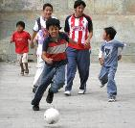

French
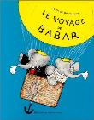
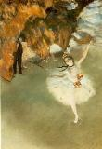
German
Any time you start a new experience, it’s helpful to think about why you are committing time and effort and what you hope to get out of it. With your child, view the following video: http://lfonetwork.uoregon.edu/supporting-languages-and-culture-learning/
Then, have your child talk about why he or she might want to learn another language and experience another culture.
You may need to prompt children based on their own interests. For example:
- What would you like to be able to tell someone in XXX in their own language?

- What do you think children in XX like to do during the summer?

- I bet they like some of the same treats as you do. What are some of your favorites? Are you ready to explore some new foods?

- I wonder if they play the same sports or video games. What do you think?

Conversations like the above set the stage for reflection on language learning and intercultural competence. You can continue to support your child during the STARTALK program by asking similar types of questions. For example,
- What does the language sound like to you? (It’s okay to let your child imitate based on intonation and common sounds, not actual words at first)

- Can you show me how to say “hello” or “good-bye”? (Be sure to ask children to include any culturally appropriate gestures that go along with the words.)

- Did you notice anything about the way the language is written?

- What sorts of foods are you eating at the program? Do you think we could find some of them in the market?

- Any new words? Anything interesting about the culture?

You can extend language and culture learning at home during and after the summer experience by:

- Checking out children’s literature in translation from the library. If you are heritage speakers, visit the free reading website: http://en.childrenslibrary.org/

- Encouraging friendships with families of different backgrounds (through local community organizations or e-pal sites)

- Sampling foods and age-appropriate arts and media of the culture (e.g., music, exhibits, TV shows, movies), live or virtually.

- Engaging in scrapbooking or journaling to track language and cultural encounters.

After the summer STARTALK program, will there be opportunities for continued learning? Consider advocating for a community or school-based program. Click here for the National Network for Early Language Learning (NNELL). You’ll find a list of current officers and advocacy tools. The Center for Applied Linguistics (CAL) also has a vast array of early language learning resources.
Thank you for taking the time to explore other languages and cultures with your child!

