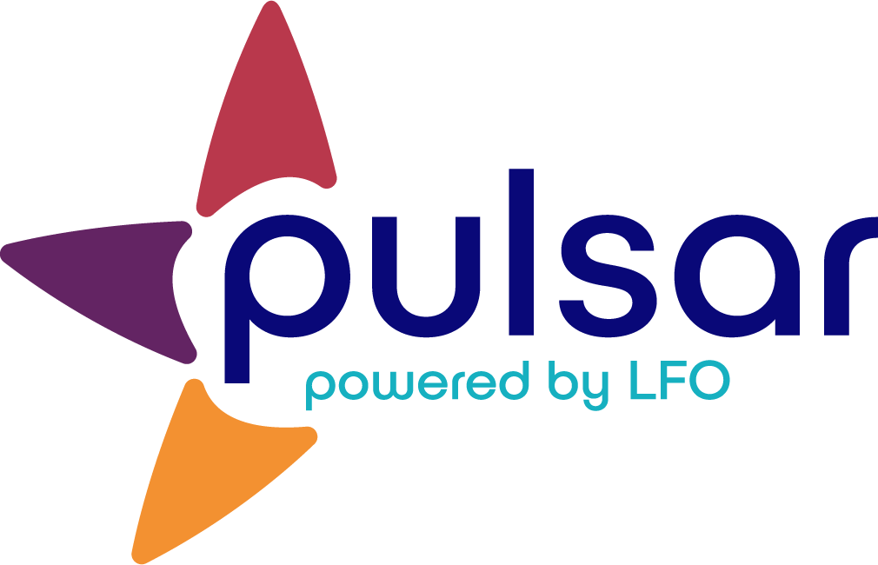

Acquire: Implementing Pulsar in the Classroom
Training Resource for Veteran Teachers

Acquire: Implementing Pulsar in the Classroom
[Subtitle]
If you are like most teachers who are new to using language learning portfolios, you might be wondering how to incorporate Pulsar into your classroom. Given your implementation of STARTALK Principles, target-language use, and student mentoring and feedback, you have a lot to think about!

Luckily, designing your implementation approach is relatively simple! You just need to decide upon 1) the frequency with which your students will upload evidence, 2) the type of evidence students will upload and save, and 3) the tools (computers, mobile devices, or both) that you will use for evidence capture.

Frequency
Recent research (Ziegler and Moeller, 2012) has shown that language learning portfolios like Pulsar promote gains in task value, self-regulated learning, and student motivation if learners interact with them regularly (at least four times a semester). Use the table below to determine the minimum frequency that is right for your STARTALK program.

Program Length | Number of Pulsar Uses | When?*
2 weeks | 4 | Week 1: T, R  Week 2: W, F
3 weeks | 4 | Week 1: F  Week 2: F  Week 3: W, F
4 weeks + | Once a week | The end of the week

Evidence Selection
Teachers may find Stage 2 of the SOPHIE curriculum template useful when deciding what evidence to have students upload. As an entry point to using Pulsar, teachers may want to begin by directing learners to use the evidence created as performance assessment tasks when they upload (in addition to any other evidence created for other tasks). However, allowing for more learner autonomy is fine, and even recommended depending on how the teacher intends to use the evidence (e.g., to provide individual feedback, to provide global feedback, or to simply give learners the opportunity to reflect).

There are no file size limitations on Pulsar. However, teachers may find that their local networks do not allow for all students to upload large files (like video files) simultaneously. Thus, they may want to consider using smaller sized files (audio, text, or picture files) and/or having learners upload evidence on rotation (e.g., five or so uploading at a time).

The STARTALK Program, administered by the National Foreign Language Center at the University of Maryland and the U.S. Department of Education Title VI under grant #P229A140004, supports development of LinguaFolio Online. Contents do not necessarily represent the policy of the U.S. Department of Education nor imply endorsement by the federal government.

