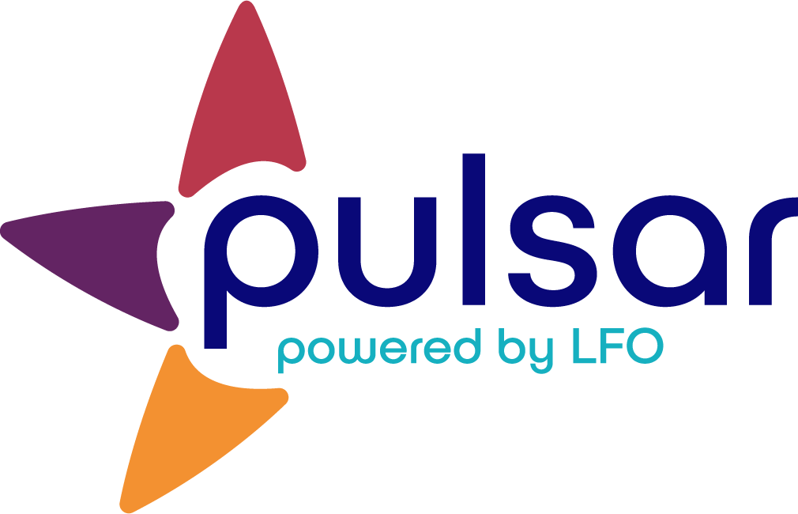

Acquire: Purpose and Benefits of Pulsar
Training Resource for New Teachers

Acquire: Purpose and Benefits of Pulsar
[Subtitle]

The Purpose and Benefits of Pulsar

Pulsar’s Purpose

While portfolio connotes summative assessment, Pulsar exists to document a learner’s journey and facilitate goal setting, self-evaluation, and meaningful reflection. A learner’s ability to engage in this process has been shown to yield gains in both language proficiency (Moeller, Thieler & Wu, 2012) and across subject levels (Clarke, 2013).

It can be difficult for practitioners to step back from formal evaluation and feedback, but many STARTALK programs that have successfully implemented language learning portfolios like Pulsar rarely engage in the formal evaluation of evidence uploaded by learners. Indeed, Pulsar is NOT for grading. Teachers review the evidence to guide instruction and tp provide the class with feedback, but the purpose of the evidence uploaded by learners is to facilitate their own goal setting, reflection, and growth. How the students themselves view their evidence is most important.

Benefit 1: Orientation to proficiency
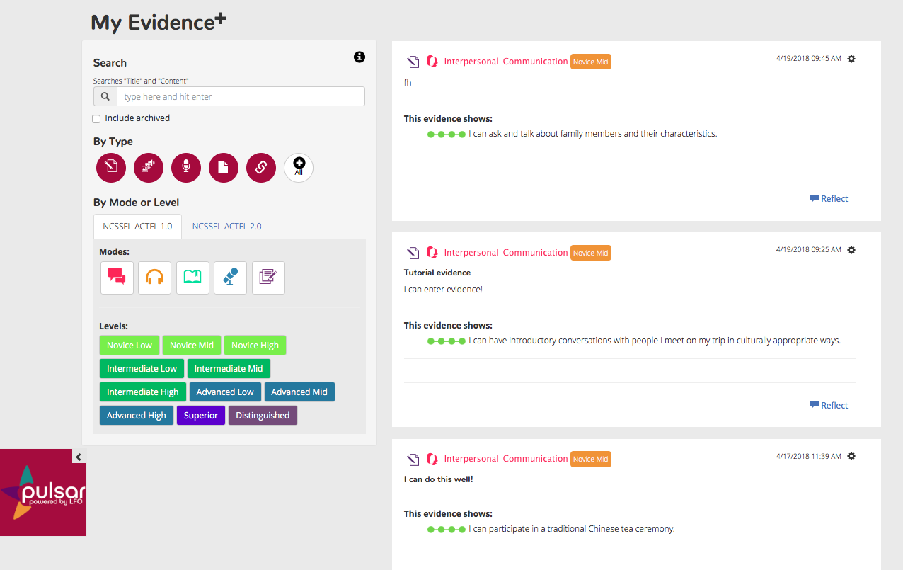
By referring to Program Can-Do Statements and Lesson Can-Do Statements throughout your day, you help your students to understand that language learning is more than memorizing lists of words and verb conjugations. They will begin to understand language use in practice in meaningful situations. As they upload their work into Pulsar, they will begin to understand the differences and connections between proficiency levels and modes of communication.

Benefit 2: Unpacking the learning process

A positive result of using Can-Do Statements and Pulsar in concert is that students gain the ability to clearly articulate what they are learning. This improved understanding comes from considering 1) what they should accomplish and 2) what evidence shows that they have accomplished or are working towards accomplishing it (or are working towards accomplishing it).

As you work with learners, have them consider what is contributing to or preventing their desired level of achievement For example, consider the Can-Do Statement, I can present about a holiday that is important to the local heritage community. If a learner captures an audio file of this Can-Do Statement in practice in which he or she struggled to use words associated with the holiday, he or she can set a small, achievable, personal goal to learn more vocabulary next time.

Benefit 3: Facilitating a growth mindset and learner empowerment

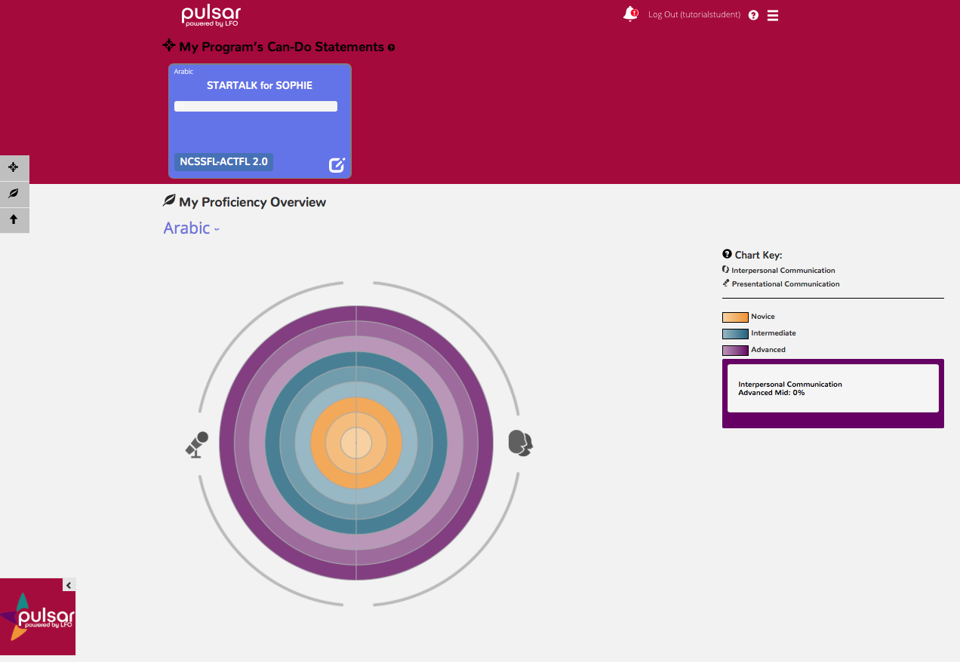
Learners who believe they can grow their intelligence outperform those who believe intelligence to be fixed (Dweck, 2015). The Pulsar platform facilitates a growth mindset because it directs your learners to focus on what they CAN do, rather than what they can’t do yet. For example, consider “My Proficiency Overview,” a feature on the dashboard of the learner platform. On this graphic, learners will see their graphs fill in over time, as more and higher quality evidence is created. Many educators note how motivating it is for their students to have a visual representation of their growth.

Additionally, learner autonomy within Pulsar is facilitatory of a sense of learner empowerment. Learners get to select their own evidence to prove what they can do and do the work of reflecting to connect what they DO to what they learn.

The STARTALK Program, administered by the National Foreign Language Center at the University of Maryland and the U.S. Department of Education Title VI under grant #P229A140004, supports development of LinguaFolio Online. Contents do not necessarily represent the policy of the U.S. Department of Education nor imply endorsement by the federal government.

