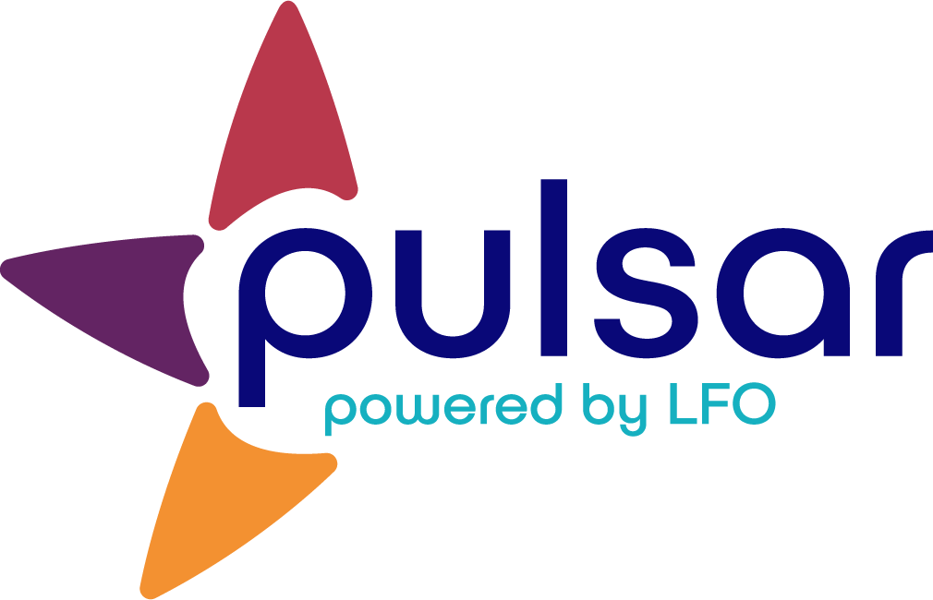

Acquire: Collecting Evidence Answer Key
Training Resource

Acquire: Collecting Evidence Answer Key
[Subtitle]
1. True or False? Teachers should mandate what evidence students upload to Pulsar.
- True
- False
The correct answer is B. While some teachers may want to select certain assignments that they want students to upload to Pulsar, the intent of Pulsar is to collect evidence of the student’s learning and growth overtime. Teachers should allow students autonomy in selecting evidence, provided that the evidence is of language proficiency (e.g.., conversation recordings and emails) and not simply language knowledge (e.g., verb charts).

2. Imagine that you are new to language learning portfolios. Where is the first place you should look on the SOPHIE curriculum template when considering what evidence learners might upload to Pulsar?
- Stage 1
- Stage 2
- Stage 3
- None of these

Feedback: The correct answer is B. While evidence may come from a variety of proficiency-oriented activities, the Performance Assessment Tasks articulated in Stage 2 are the perfect place to begin when thinking about evidence that might be created.

3. What guidance related to uploading to Pulsar should you provide students?
- A basic understanding of language proficiency
- A basic understanding of the levels of language proficiency
- A basic understanding of what might be considered evidence of language proficiency
- All of the above
Feedback: The correct answer is D. Learners need to understand language proficiency, what it means to be at a specific proficiency level, and what artifacts might serve as evidence for their proficiency.

4. Consider the evidence uploaded for the following Can-Do Statement: I can ask for help at the supermarket. The student rated the evidence as “Can do well.”
Mandarin
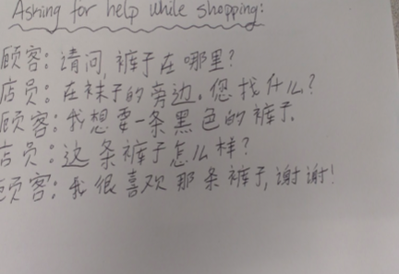
English
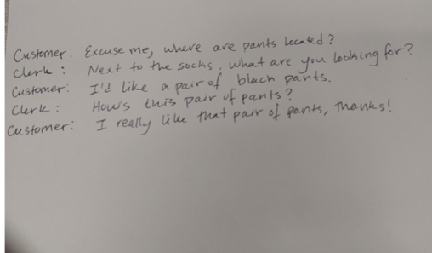
- Does this evidence indicate interpersonal proficiency at a “Can-do well” level?
- Yes.
- No.
- Depends.
The correct answer is C. The evidence might be a transcript of the conversation the student had at a clothing store. In that case, the evidence is not only evidence of the student’s ability to ask for help, but also evidence of the student’s writing mechanics. However, if the evidence is a script the student wrote and read from when having the conversation, the evidence might prove that the student “Can do with help,” rather than “Can do well” or even “Can do.”

Still, it is important to remember that the evidence that the learner uploads is intended to document his or her journey. There should be considerable autonomy in evidence selection. If the student wants feedback on a spoken conversation he or she had, an audio recording or video recording would have been more appropriate. However, if the student chose this evidence for the purpose of supporting his or her own self-reflection, then whether or not the conversation can actually be heard is not as important.

The STARTALK Program, administered by the National Foreign Language Center at the University of Maryland and the U.S. Department of Education Title VI under grant #P229A140004, supports development of LinguaFolio Online. Contents do not necessarily represent the policy of the U.S. Department of Education nor imply endorsement by the federal government.

