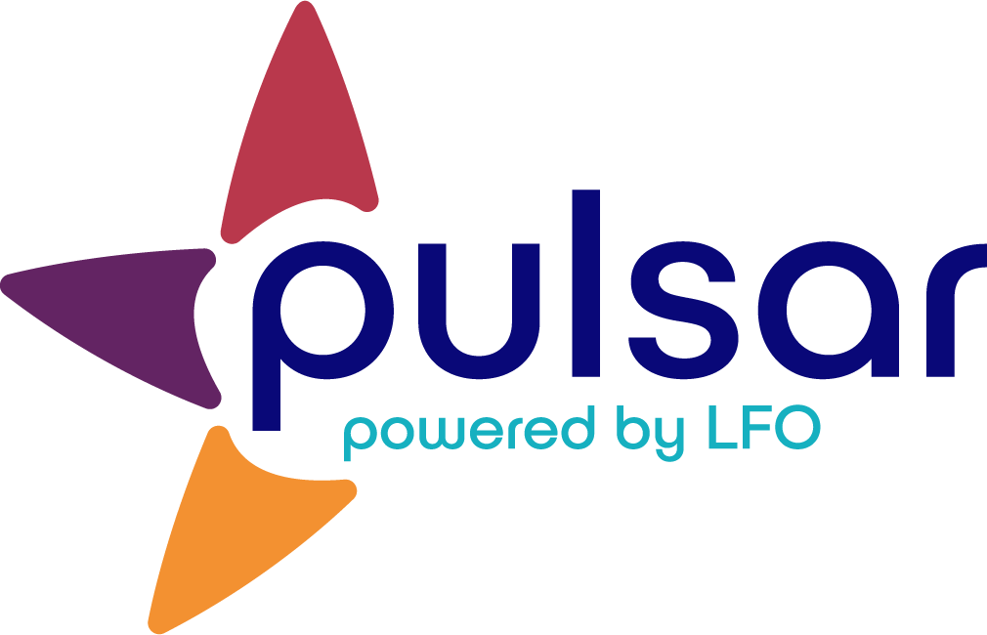

Apply: Perform and Explain the Basic Functionalities of Pulsar
Training Resource for New Teachers

This resource includes activities you should be able to complete in order to be able to confidently engage in and explain the basic functionalities of Pulsar.
Using Pulsar: Basic Functionalities

Do the following tasks. Feel free to use these tutorials to help you.

- Create your teacher account. If you cannot find your group, please contact your program director to create it.

- Create a student account for yourself.

- Create your students’ accounts or schedule time for them to create their own accounts during class.

- Upload evidence from your student account to your Can-Do Cluster using the web platform. Explore the student web platform for an additional 10 minutes. If you don’t see the Can-Do Cluster for your group, it is because your curriculum template has not been approved yet. You can either create your own Can-Do Cluster in order to practice or return to this activity later.

- Download the Pulsar app from the App Store or Google Play. Use your student account to log in and upload evidence to your Can-Do Cluster. Explore the mobile app for an additional 10 minutes. If you can, try to repeat this step with another device so that you can experience both the Android and iOS platforms.

- Log in to your instructor account (web platform only) and give yourself feedback on the evidence you uploaded as a student.

The STARTALK Program administered by the National Foreign Language Center at the University of Maryland and the U.S. Department of Education Title VI, under grant #P229A140004, support development of LinguaFolio Online. Contents do not necessarily represent the policy of the U.S. Department of Education nor imply endorsement by the federal government.

